Your Business Name Goes Here
Your Website.com 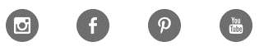
The skills that I have and the skills that I need…
SKILL | JOB TITLE | HOW THE JOB WILL GET DONE
Leadership | CEO | Provide direction for the team via regular meetings and updates
Oversight and Business Planning | CEO | Long, medium and short term goals will be established at regular intervals (quarterly)  Recognizing what was done well, and what we need to improve upon  Listen to various team members
Human Resources | HR Manager | Identifying where talent is needed and the skills required to fill that need
Sales and Marketing | Sales and Marketing Director
Finance | CFO

