Your Business Name Goes Here
Your Website.com 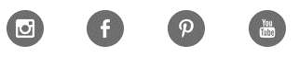
Company Description
______________________ is a _____________________ business that is a…
We use a number of media platforms to reach our audience including:
- Instagram
- Pinterest
- Facebook
- You Tube
- And, of course, our website ____________________.com
We want to be in business as ….

